Mini Project: Amazon S3 trigger to invoke a Lambda function

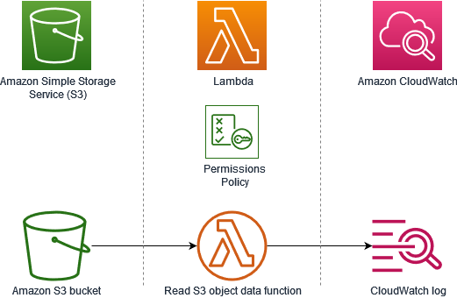

This tutorial demonstrates how to:
- Create an Amazon S3 bucket.
- Create a Lambda function that returns the object type of objects in an Amazon S3 bucket.
- Configure a Lambda trigger that invokes your function when objects are uploaded to your bucket.
- Test your function, first with a dummy event, and then using the trigger.
By completing these steps, you’ll learn how to configure a Lambda function to run whenever objects are added to or deleted from an Amazon S3 bucket.
- Create an Amazon S3 bucket:
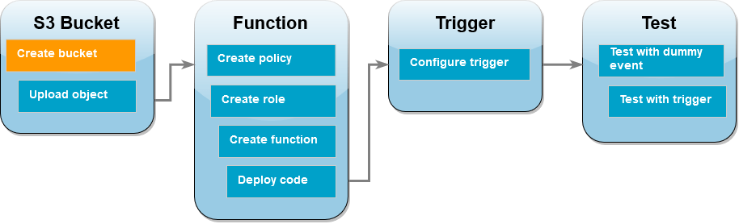
- Create a bucket, in General purpose, name (amzn-s3-demo-bucket) – disable encryption – create bucket

- Upload a test object to your bucket
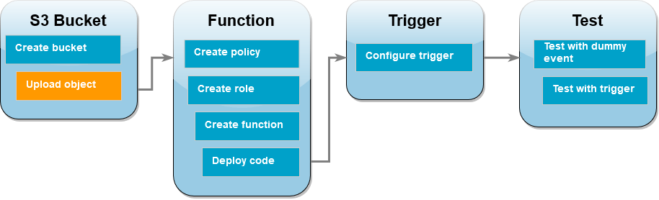
- Now, upload any files as an object

- Create a Permission Policy
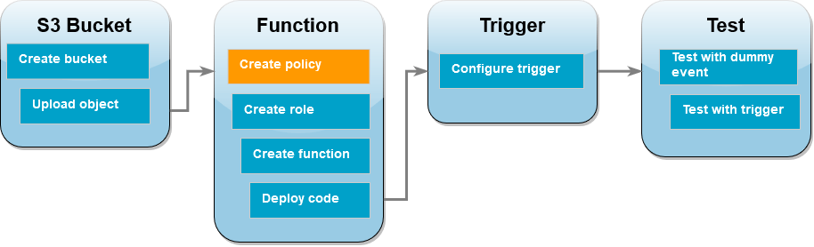
- Go to IAM Policy – Create Policy
- Choose the JSON and, paste the below custom policy
{
"Version": "2012-10-17",
"Statement": [
{
"Effect": "Allow",
"Action": [
"logs:PutLogEvents",
"logs:CreateLogGroup",
"logs:CreateLogStream"
],
"Resource": "arn:aws:logs:*:*:*"
},
{
"Effect": "Allow",
"Action": [
"s3:GetObject"
],
"Resource": "arn:aws:s3:::*/*"
}
]
}
- Review and provide a name (s3-trigger-tutorial) – create policy

- Create an execution role
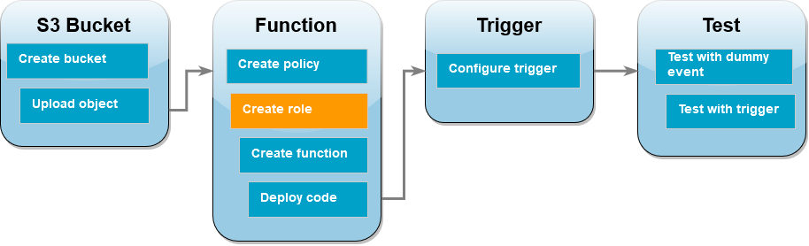
- Choose IAM role, select Lambda – next
- Select (s3-trigger-tutorial), policy which we created above step – next
- Role name (Lambda-s3-trigger-role) – create role.

- Create the Lambda function
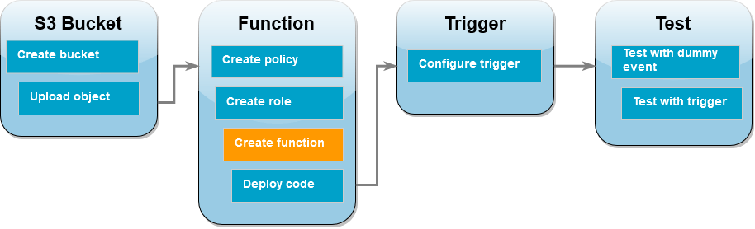
- Choose create function
- Select Author from Scratch
- Under Basic information, do the following: function name (S3-trigger-tutorial); runtime (Python 3.13); architecture (x86_64)
- Select the existing role (lambda-s3-trigger-role) – Create

- Deploy the function code
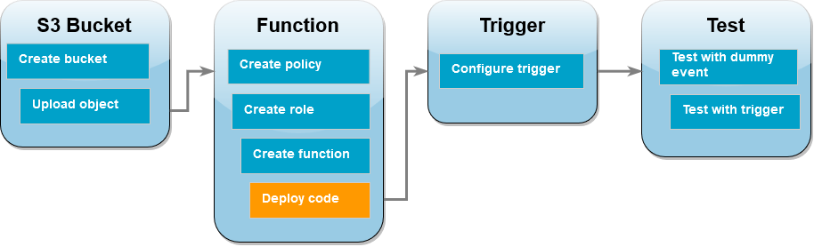
- In the Code source, paste the code below.

# Copyright Amazon.com, Inc. or its affiliates. All Rights Reserved.
# SPDX-License-Identifier: Apache-2.0
import json
import urllib.parse
import boto3

print('Loading function')

s3 = boto3.client('s3')

def lambda_handler(event, context):
#print("Received event: " + json.dumps(event, indent=2))

# Get the object from the event and show its content type
bucket = event['Records'][0]['s3']['bucket']['name']
key = urllib.parse.unquote_plus(event['Records'][0]['s3']['object']['key'], encoding='utf-8')
try:
response = s3.get_object(Bucket=bucket, Key=key)
print("CONTENT TYPE: " + response['ContentType'])
return response['ContentType']
except Exception as e:
print(e)
print('Error getting object {} from bucket {}. Make sure they exist and your bucket is in the same region as this function.'.format(key, bucket))
raise e

- Save the code (Deploy)

- Create the Amazon S3 trigger
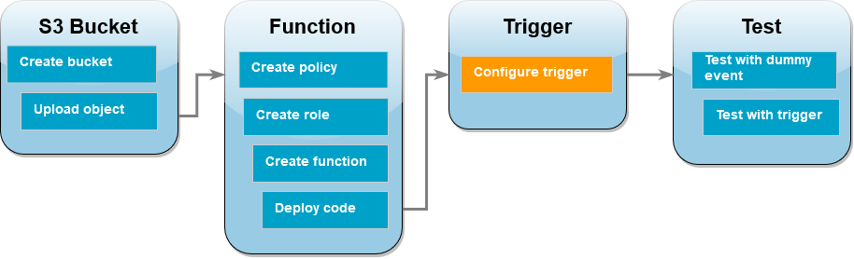
- Choose Add trigger – select S3
- Under Bucket, select the bucket you created earlier
- Under Event types, be sure that All object create events is selected
- Nder Recursive invocation, select the check box to acknowledge – Add

- Test your Lambda function with a dummy event
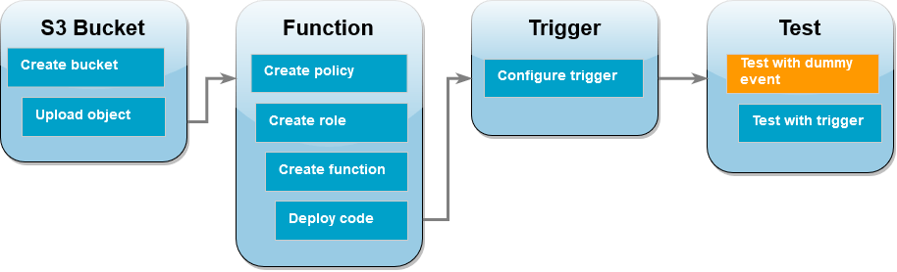
- In the Lambda console, choose the Test tab
- For Event name, enter (MyTestEvent)
- In the Event JSON, paste the following test event. [make sure to replace things accordingly]

{
"Records": [
{
"eventVersion": "2.0",
"eventSource": "aws:s3",
"awsRegion": "Bucket region",
"eventTime": "1970-01-01T00:00:00.000Z",
"eventName": "ObjectCreated:Put",
"userIdentity": {
"principalId": "EXAMPLE"
},
"requestParameters": {
"sourceIPAddress": "127.0.0.1"
},
"responseElements": {
"x-amz-request-id": "EXAMPLE123456789",
"x-amz-id-2": "EXAMPLE123/5678abcdefghijklambdaisawesome/mnopqrstuvwxyzABCDEFGH"
},
"s3": {
"s3SchemaVersion": "1.0",
"configurationId": "testConfigRule",
"bucket": {
"name": "S3 bucket name",
"ownerIdentity": {
"principalId": "EXAMPLE"
},
"arn": "arn:aws:s3:::amzn-s3-demo-bucket"
},
"object": {
"key": "Object_Key",
"size": 1024,
"eTag": "0123456789abcdef0123456789abcdef",
"sequencer": "0A1B2C3D4E5F678901"
}
}
}
]
}

- Save & Test; Make sure the function runs successfully

- Test the Lambda function with the Amazon S3 trigger
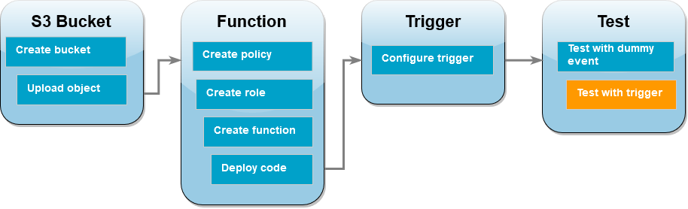
- Now, come to the S3 bucket; and upload new files
- To open CloudWatch console – choose logs – choose log groups
- Choose the log group of the function – if the functions were invoked correctly in response to your Amazon S3 trigger.

- Clean up resources
- Delete Lambda Functions
- Delete IAM Execution Role
- Delete S3 bucket
- Delete CloudWatch Log group
- Delete IAM Policy

